🌍 Global Disaster Analytics Dashboard (Power BI)
📌 Project Summary
This project presents a Global Disaster Analytics Dashboard built using Power BI to analyze worldwide disaster data from 2018 to 2024.
It provides insights into:
- Disaster frequency and trends
- Economic impact and casualties
- Response efficiency and recovery duration
- Aid and funding distribution
- Forecasting future disaster patterns
The dashboard is designed to support data-driven decision-making for disaster management and planning.

📂 Dataset Source
- Dataset: Global Disaster Data (2018–2024)
- Type: Structured dataset (CSV format)
- Contains:
  - Event ID
  - Disaster Type
  - Country & Region
  - Economic Loss (USD)
  - Casualties
  - Response Time (days)
  - Recovery Duration (days)
Note: A sample dataset is included in this repository. Full dataset may be excluded due to size limitations.

⚙️ How to Run ETL Pipeline
Step 1: Install Requirements
pip install -r requirements.txt
Step 2: Run ETL Scripts
python src/etl/01_load.py
python src/etl/02_clean.py
python src/etl/03_enrich.py
ETL Workflow:
- 01_load.py → Loads raw dataset
- 02_clean.py → Handles missing values, formats data
- 03_enrich.py → Adds calculated fields and features
Processed data will be saved in:
data/clean/

📊 How to Open Power BI Dashboard
- Go to:
powerbi/GlobalDisasterDashboard.pbix
- Open using:
- Power BI Desktop
- Interact with:
- Filters (Year, Country, Disaster Type)
- Visuals (Maps, Charts, KPIs)

📷 Dashboard Screenshots
Executive Overview
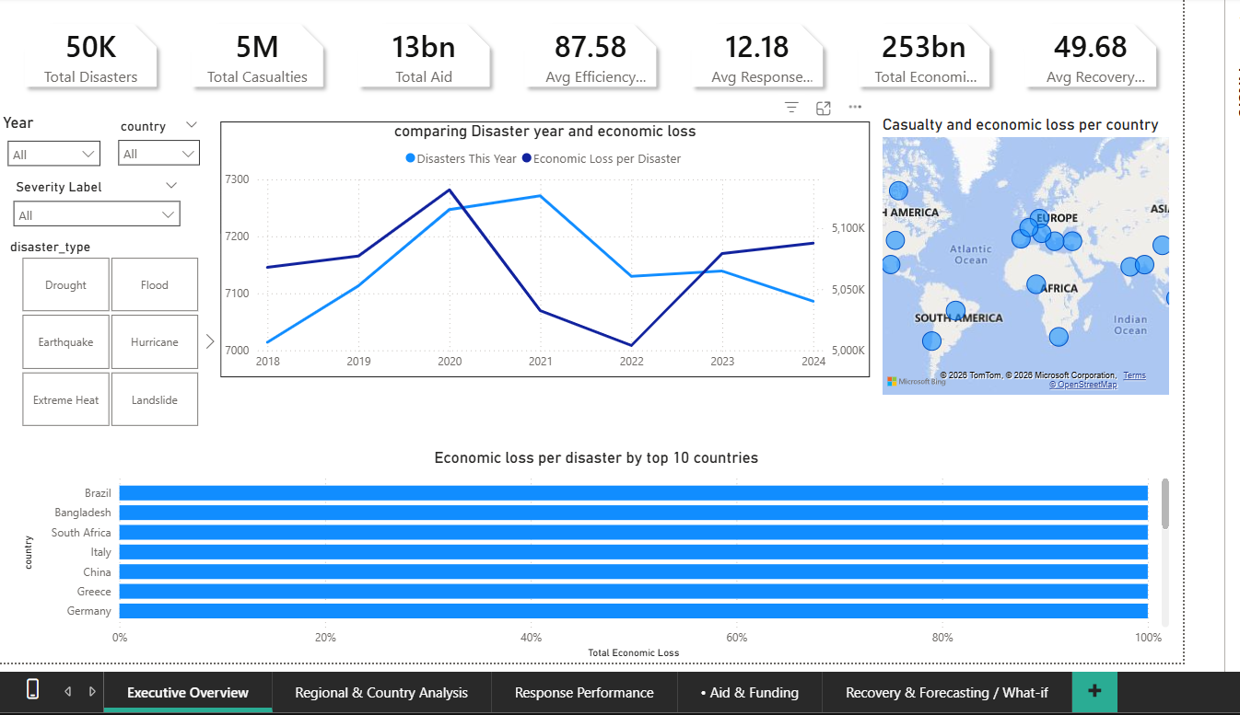
Regional Analysis
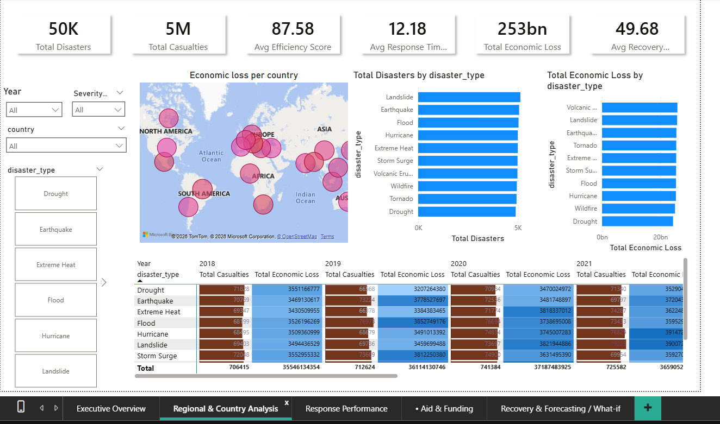

Response Performance
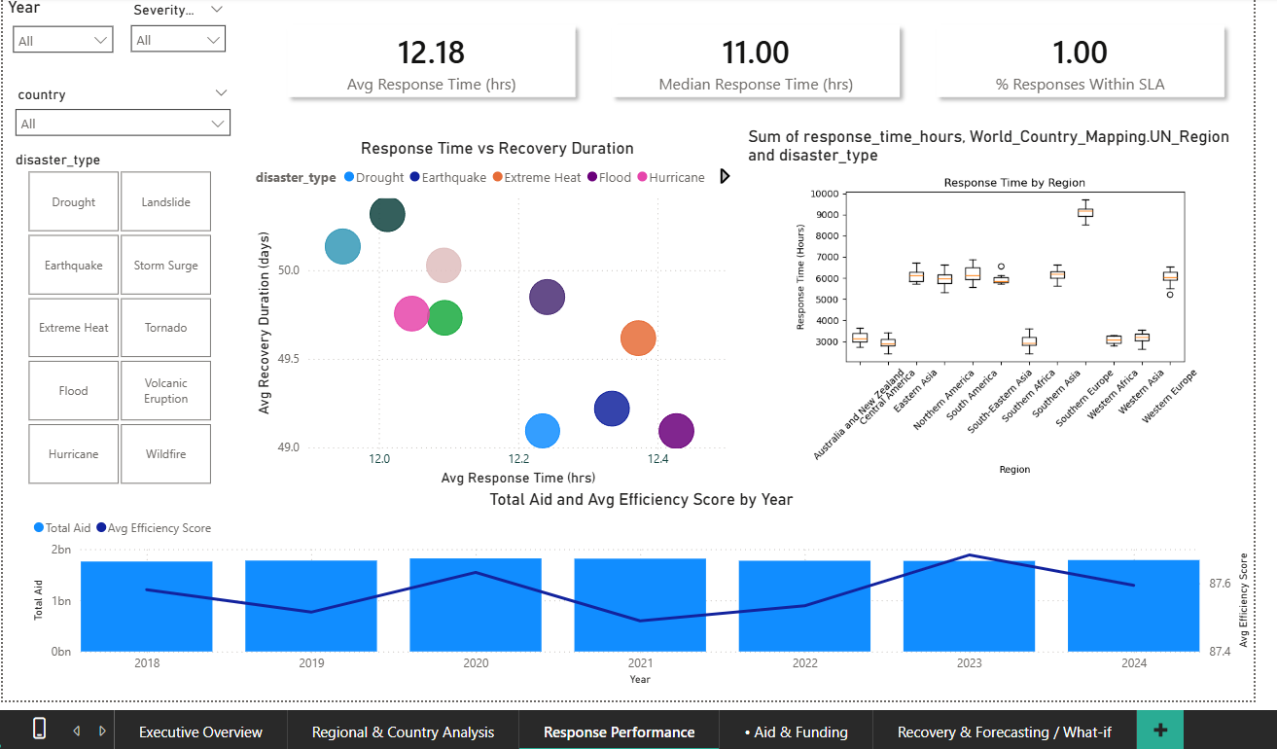
Aid & Funding
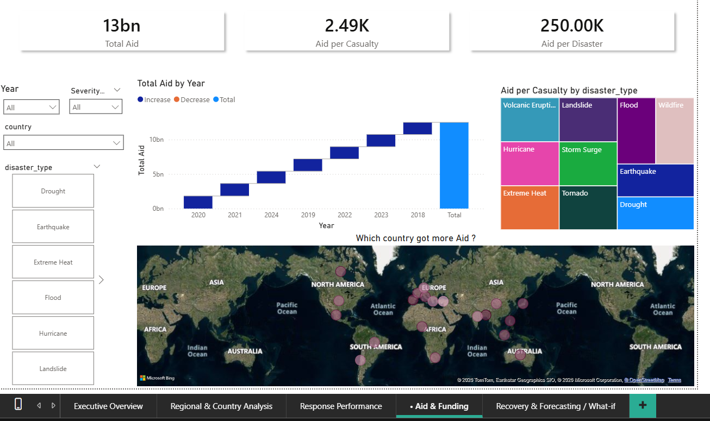
Recovery & Forecasting 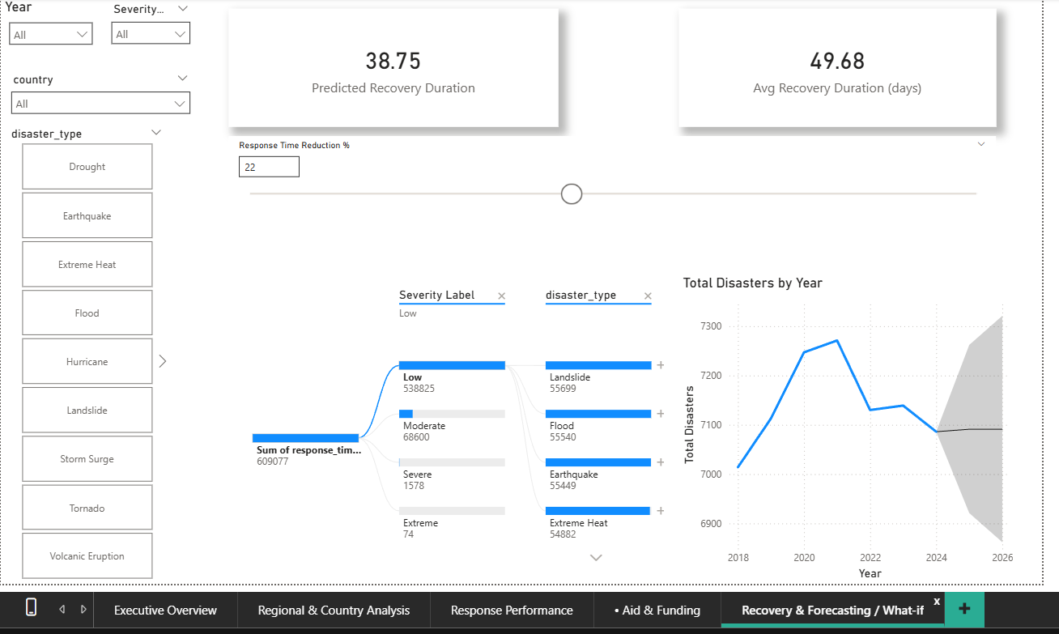

🛠️ Tools & Technologies
- Power BI
- DAX (Data Analysis Expressions)
- Python (ETL Pipeline)
- Pandas, NumPy
- Git & GitHub

📁 Project Structure
global-disaster-dashboard/
global-disaster-dashboard/
├── README.md
├── LICENSE
├── data/
│ ├── raw/
│ │ └── disasters_raw_2018_2024.csv
│ ├── clean/
│ │ └── disasters_clean_2018_2024.parquet
│ └── docs/
│ └── data_dictionary.md
├── docs/
│ └── dashboard_blueprint.png
├── src/
│ ├── etl/
│ │ ├── 01_load.py
│ │ ├── 02_clean.py
│ │ └── 03_enrich.py
│ ├── analysis/
│ │ └── eda_notebook.ipynb
│ └── utils/
│ └── country_mapping.json
├── powerbi/
│ ├── GlobalDisasterDashboard.pbix
│ └── DAX_measures.txt
├── notebooks/
│ └── forecasting_example.ipynb
├── tests/
│ └── test_data_quality.py
├── requirements.txt
└── .github/
└── workflows/
└── ci.yml

🧠 Key Insights
- Insight: “Country A accounts for 28% of total economic loss from 2018–2024 but only 10% of total aid.”
  - Interpretation: Aid distribution is not proportional to economic impact.
  - Recommendation: Investigate barriers to aid delivery to Country A; re-balance aid channels.
- Insight: “Average response time in Region X is 96 hours vs global average 48 hours; recovery duration is 1.9× longer.”
  - Interpretation: Slower responses correlate with longer recovery.
  - Recommendation: Establish regional response hubs, pre-position supplies to cut response time.
- Insight: “Floods cause 40% of incidents but wildfires have 3× the average economic loss per event.”
  - Interpretation: Frequency ≠ severity; resource allocation should consider per-event impact as well as frequency.
  - Recommendation: Reallocate specialized firefighting and insurance resources.
- Insight: “Events with aid > $1M have 15% higher efficiency score and 20% shorter recovery on average.”
  - Interpretation: Larger aid amounts improve operational performance, but causality needs careful testing.
  - Recommendation: Fast-track funding approvals for major incidents; monitor utilization.
- Insight: “Top 5 donors supply 70% of aid, but aid-per-capita in several affected countries remains low.”
  - Interpretation: Aid concentration among donors may miss vulnerable small countries.
  - Recommendation: Set aside a proportional emergency fund for low-aid countries.
- Insight: “Response time shows high variance for earthquake events (large boxplot spread).”
  - Interpretation: Earthquake response protocols may be inconsistent.
  - Recommendation: Standardize earthquake rapid response protocols across responders.
- Insight: “Recent years show a rising trend in disaster frequency in Coastal Regions, with increasing economic loss.”
  - Interpretation: Possibly climate-driven trend; need adaptation investment.
  - Recommendation: Prioritize coastal resilience programs and early warning systems.
- Insight: “High efficiency score correlates to shorter recovery only up to a point; beyond very high aid amounts, marginal recovery improvement diminishes.”
  - Interpretation: Diminishing returns on aid; efficiency matters as much as volume.
  - Recommendation: Focus on allocation efficiency, capacity building, and transparency.

🧪 Data Quality Checks
- Data types & parsing
  - Ensure EventID is unique and text/ID typed.
  - Parse EventDate into date data type; extract Year, Month, Quarter columns.
  - Ensure numeric fields (Casualties, EconomicLoss, AidAmount, ResponseTimeHours, RecoveryDurationDays, EfficiencyScore) are numeric.
- Missing values
  - Identify NULLs per column. Strategy:
    - If EventID, EventDate, or Country missing — drop or flag as incomplete.
    - If Casualties or EconomicLoss missing — impute as 0 only if confirmed; better: flag and treat separately in visuals.
    - If ResponseTimeHours missing — do not include in averages unless imputed; create a flag ResponseTimeKnown.
- Duplicates
  - Check for duplicate EventID or same (EventDate, Country, Location, DisasterType). Remove exact duplicates.
- Standardize categorical fields
  - Normalize DisasterType (e.g., floods, flood, Flood -> Flood).
  - Normalize Country names (use ISO country names or codes).
  - Create Region mapping (continent/UN region) for each country.
- Units & currency
  - Ensure EconomicLoss and AidAmount use same currency & units (e.g., USD). If mixed, convert to single currency; adjust for scale (thousands, millions).
  - If comparing across years, consider inflation-adjusted economic loss (adjust to constant year USD).
- Outliers & validation
  - Flag extreme values (e.g., economic loss beyond reasonable range). Validate against external sources if possible.
  - Ensure EfficiencyScore in expected range (e.g., 0–100). Clip/flag out-of-range values.
- Date consistency & ranges
  - Ensure event dates fall between 2018-01-01 and 2024-12-31. Flag events outside.
- Geographic enrichment
  - Add latitude/longitude for mapping if available; otherwise add centroid coordinates by country for choropleth/bubble map.
- Create calculated fields
  - SeverityIndex (composite score): normalized weighted sum of casualties, economic loss, and severity rating (if exists).
  - Year, Month, Quarter, WeekOfYear.
  - ResponseTimeKnown boolean, HasAid boolean, IsMajor (SeverityIndex threshold).
- Audit trail
  - Add Source and IngestDate columns for traceability.
  - Keep raw original file in data/raw/ and processed file in data/clean/.

🚀 Future Improvements
- Real-time data integration
- Advanced machine learning forecasting
- Deployment on Power BI Service
- API-based data ingestion

👨‍💻 Author
Shubh
BCA Student | Data Analyst

⭐ Support
If you found this project useful, consider giving it a ⭐ on GitHub!

